#### 21UIT001 AASIYA BANU A J

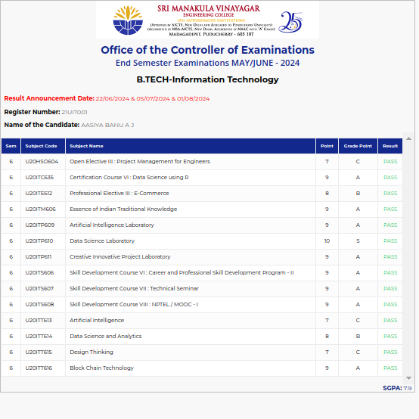

#### 21UIT003 ABISHA G

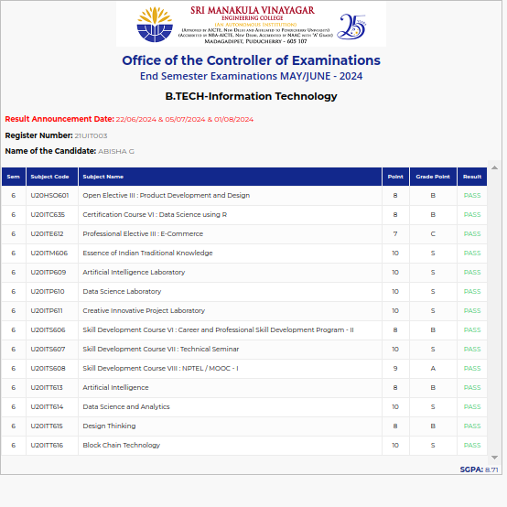

#### 21UIT006 AKASH P

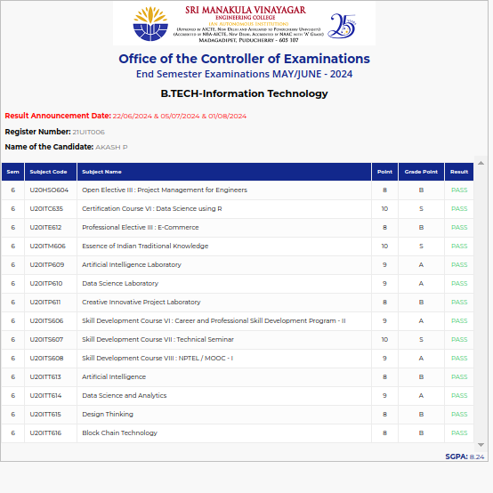

#### 21UIT012 ANNIE ROSE A

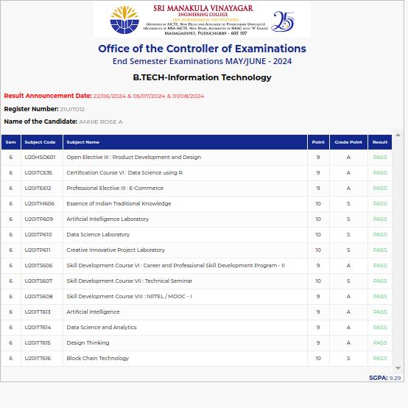

#### 21UIT014 ARAVINDAN R

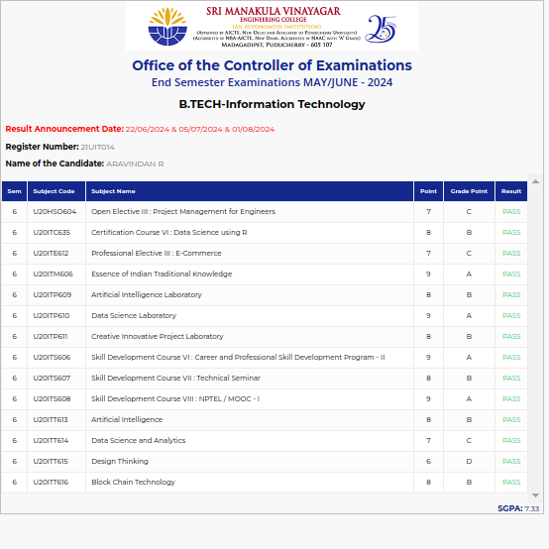

#### 21UIT016 ARUN KUMAR S

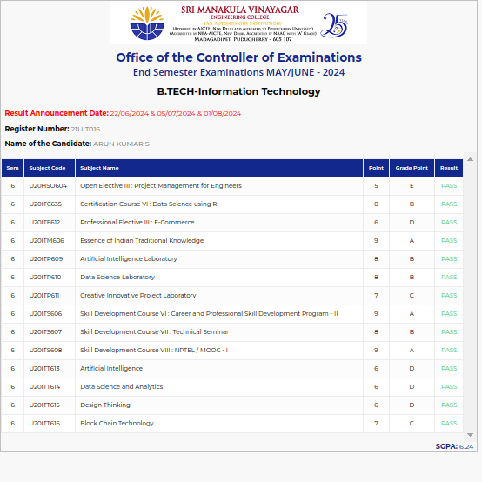

#### 21UIT018 ARUNACHALAM A

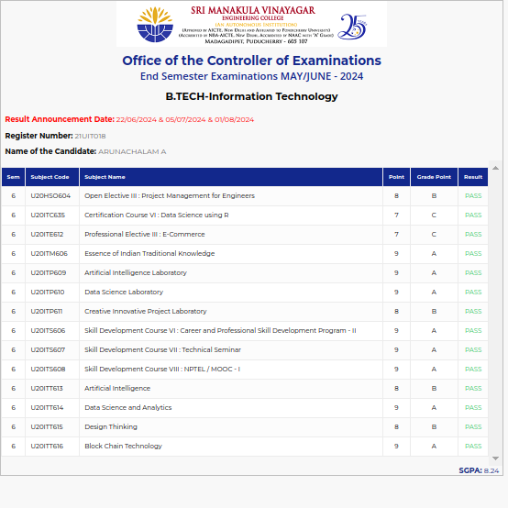

#### 21UIT020 AVILA JAYA SEBASTINA V

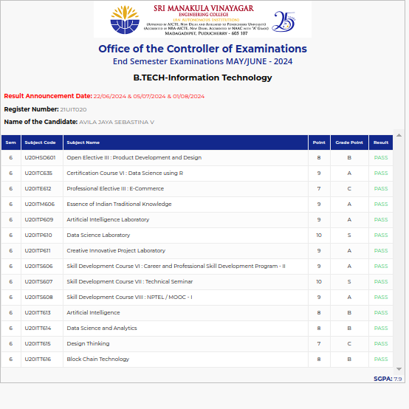

#### 21UIT023 BARANIRAJ G

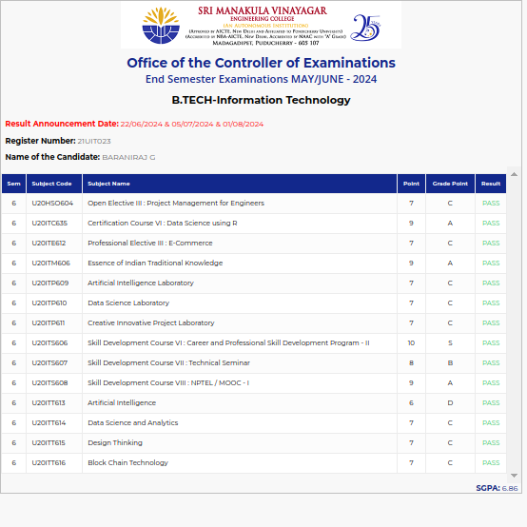

#### 21UIT028 DEVASHRI G

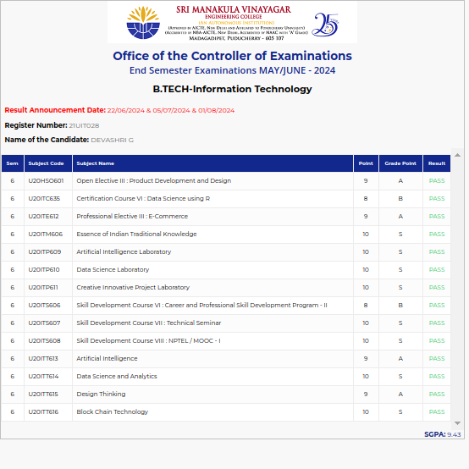

#### 21UIT034 DIVINSTAR S

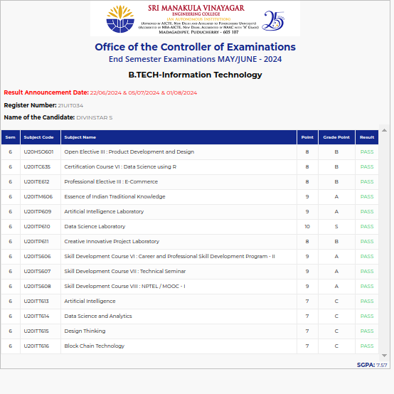

#### 21UIT035 DURGESHWAR M

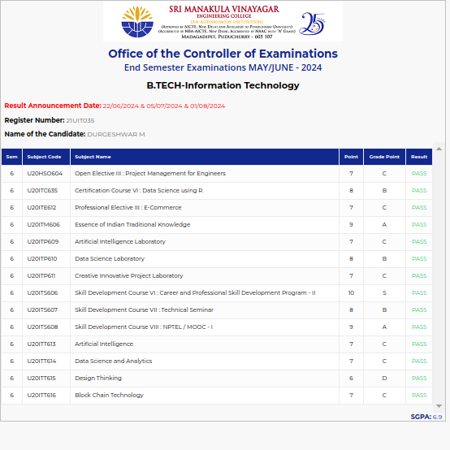

#### 21UIT042 GOKULNATH S

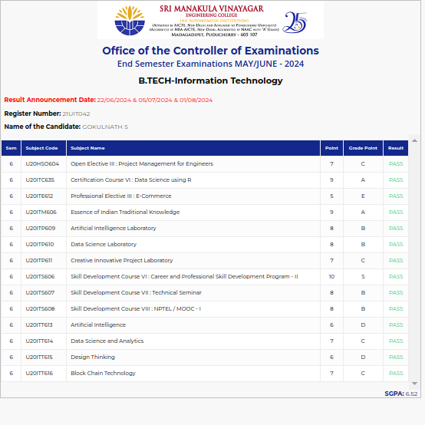

#### 21UIT043 GOKULRAJ R

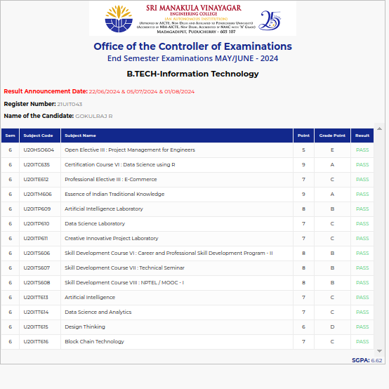

#### 21UIT046 HARINATH P

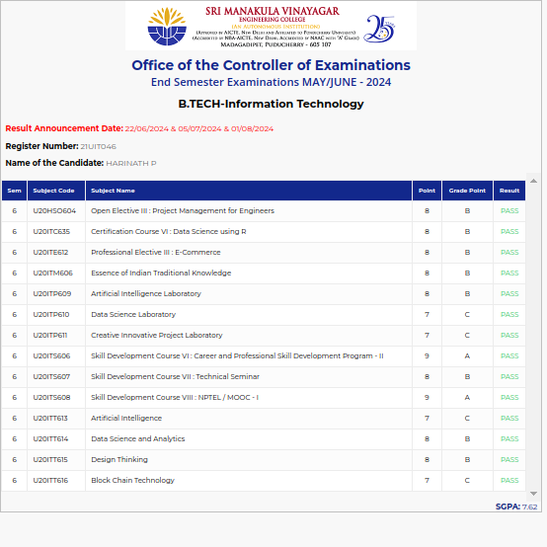

#### 21UIT047 HARINI B

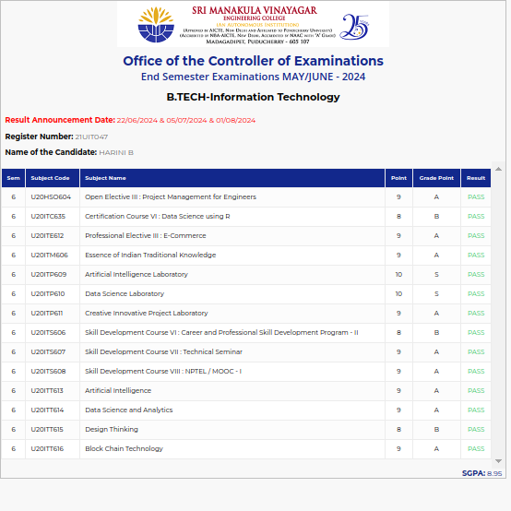

#### 21UIT048 HARINI S

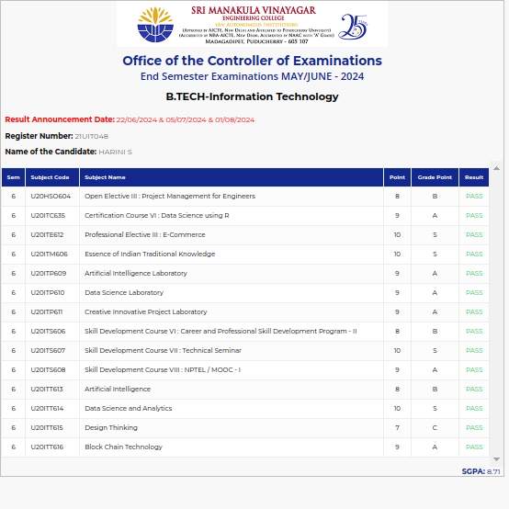

#### 21UIT051 HEMAPRABHA K

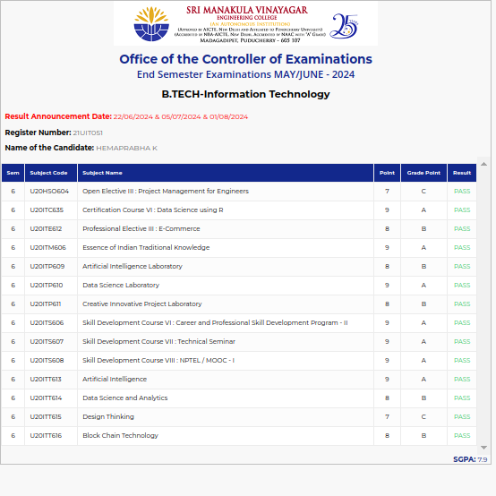

#### 21UIT054 ISABEL L

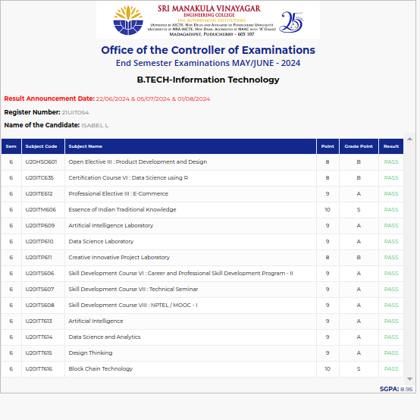

#### 21UIT055 JAIKRISHNAN M

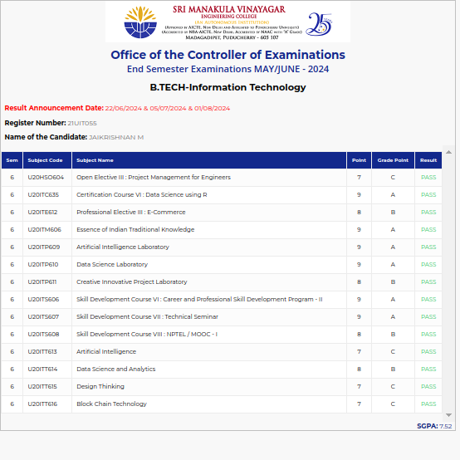

#### 21UIT056 JAMALUDEEN R

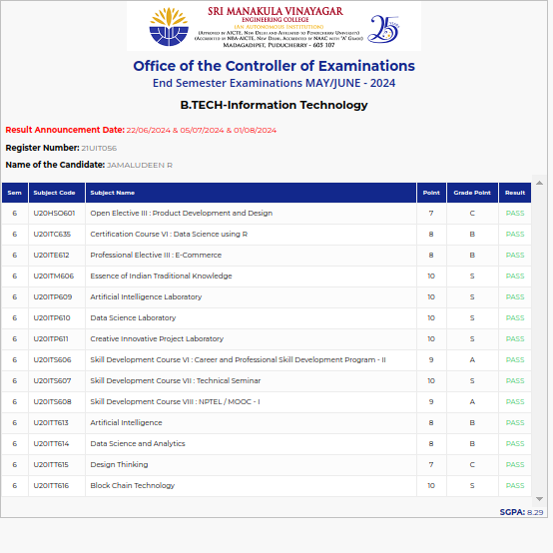

#### 21UIT058 JOSHVA JAGAN A

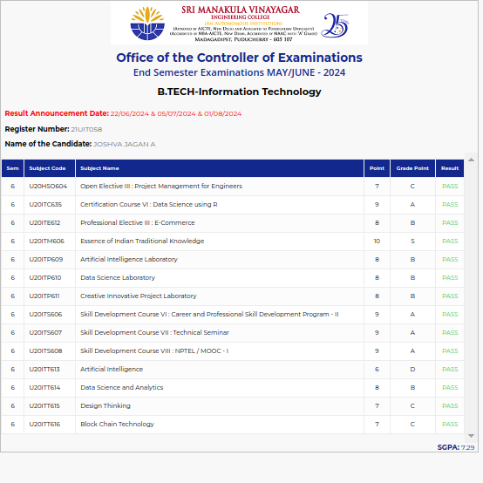

#### 21UIT062 KAUSHIK K

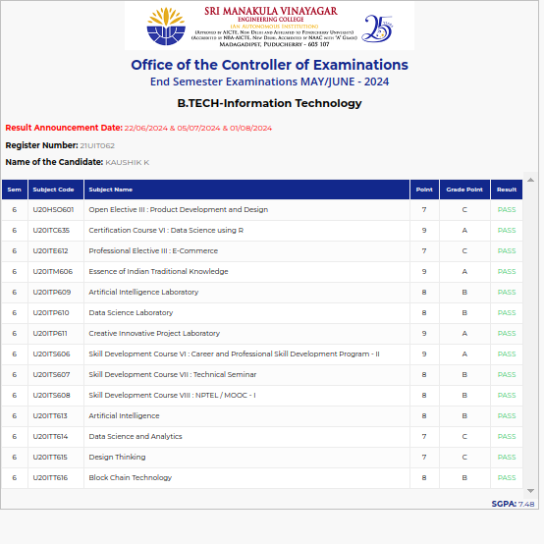

#### 21UIT067 KEERTHANA B

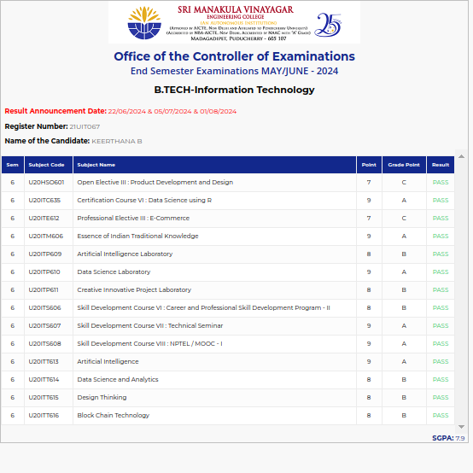

#### 21UIT068 KEERTHANA R

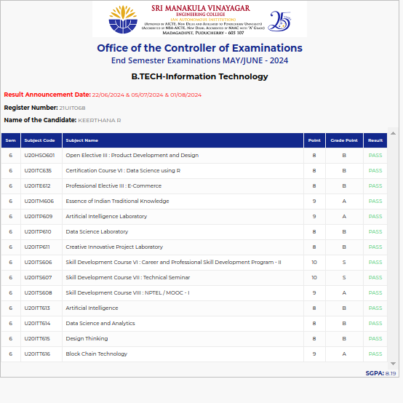

#### 21UIT072 KIRANSARVESH R S

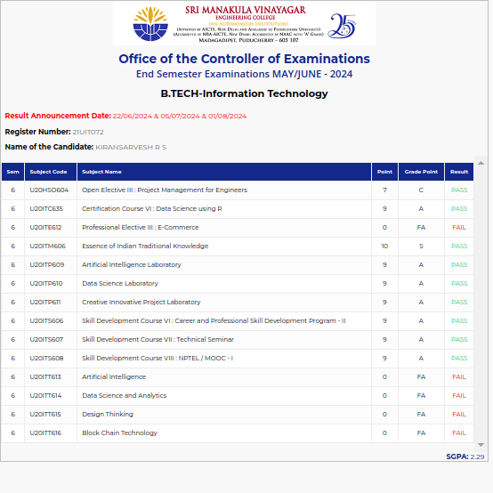

#### 21UIT074 KIRUTHIKA C

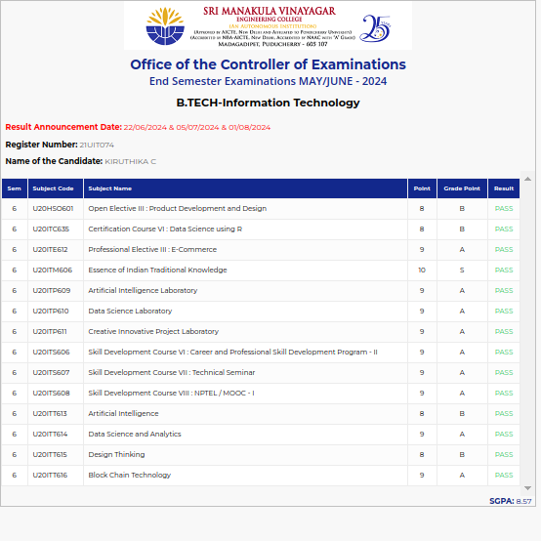

#### 21UIT080 LOGESHWARAN K

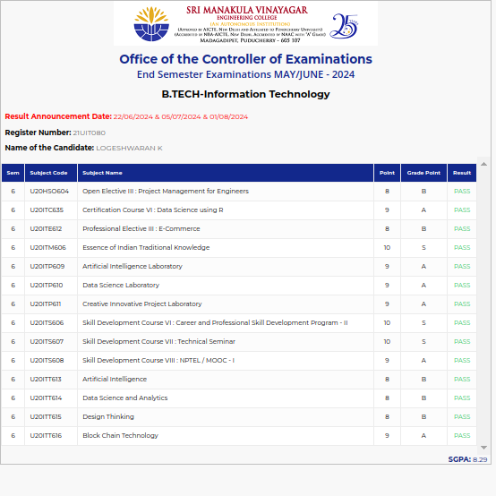

#### 21UIT088 MOHAMED NOORUL AMEEN A

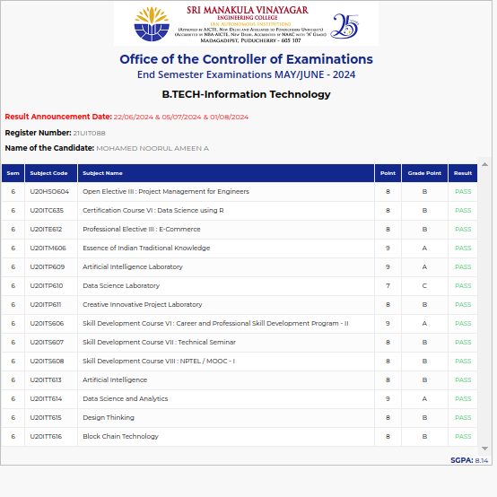

#### 21UIT089 MOHAMED SHALIK S

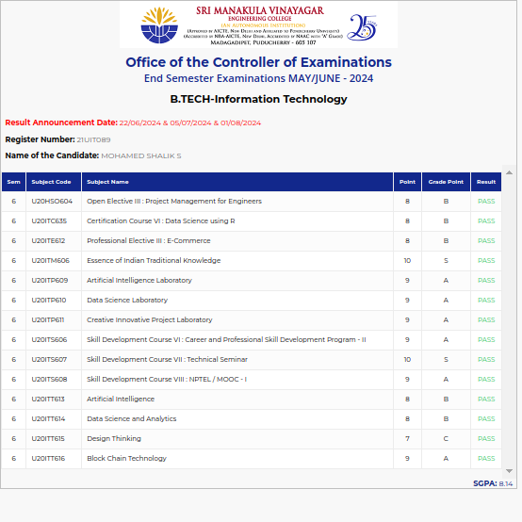

#### 21UIT094 MOSIKEERAN T

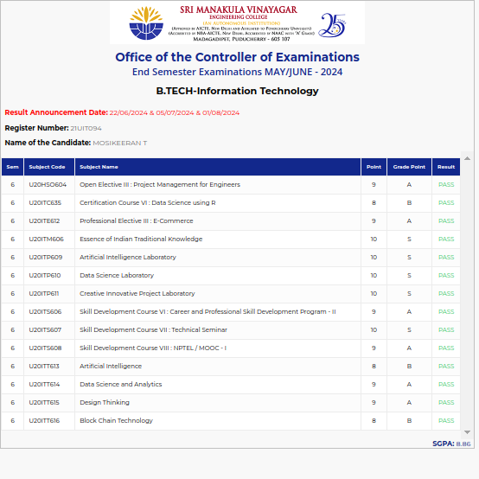

#### 21UIT095 MUAATH K

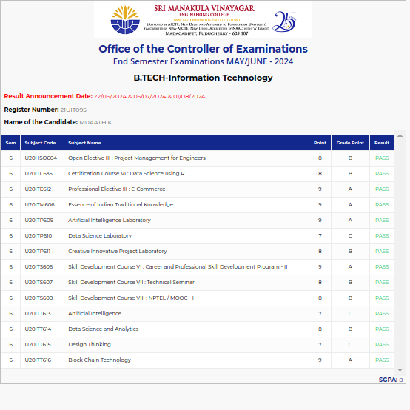

#### 21UIT096 NANDANA K P

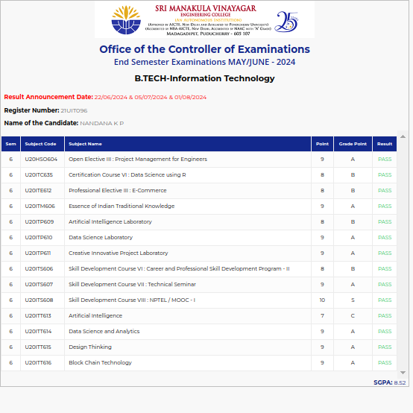

#### 21UIT101 NISHA M

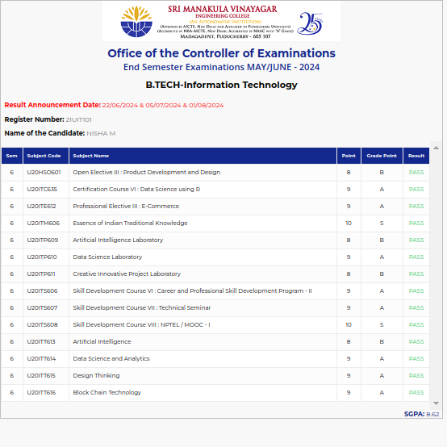

#### 21UIT104 NIVETHITHA S

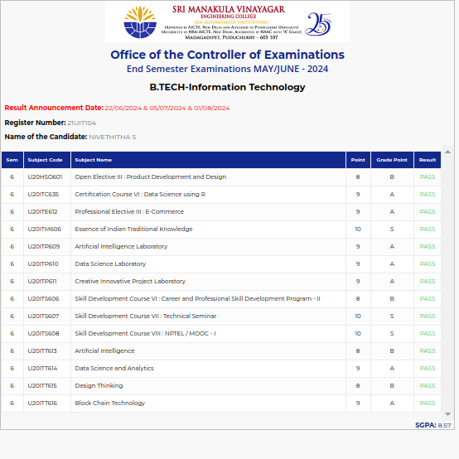

#### 21UIT105 OVEYA I

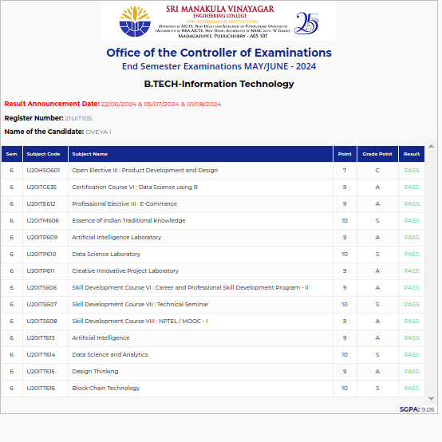

#### 21UIT106 PADMASRI V

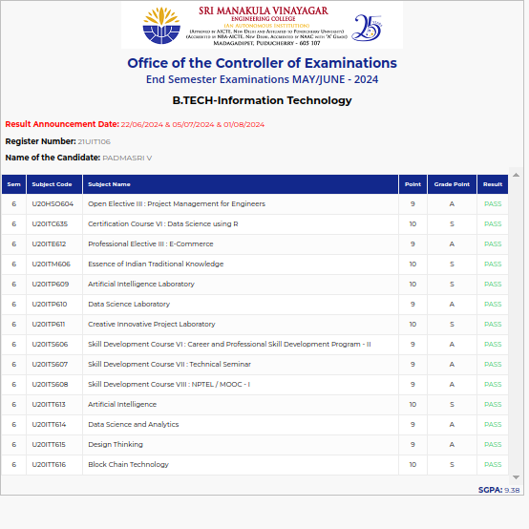

#### 21UIT112 PRAVINKUMAR R

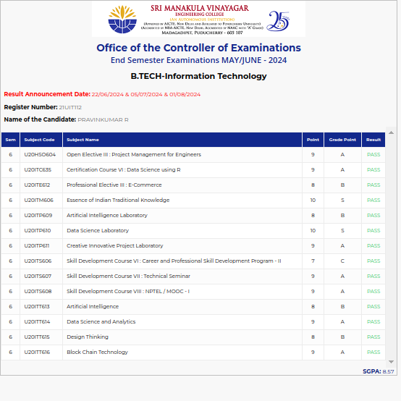

#### 21UIT117 PRIYADHARSHAN R

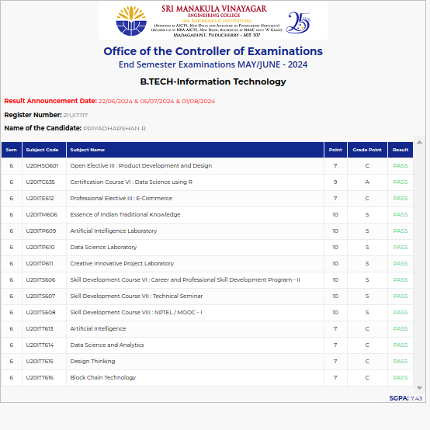

#### 21UIT118 PRIYANKA S

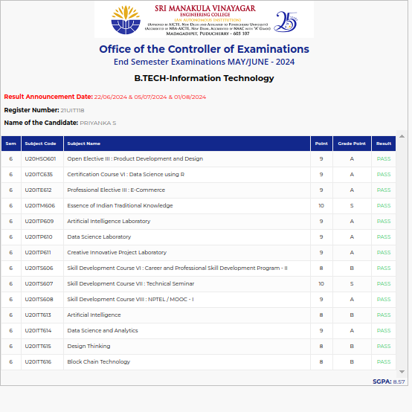

#### 21UIT121 RAGUL KRISHNA C

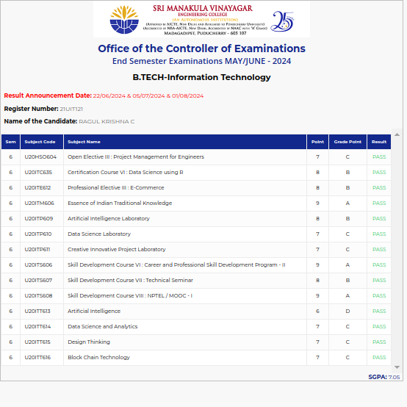

#### 21UIT123 RAMACHANDRAN K

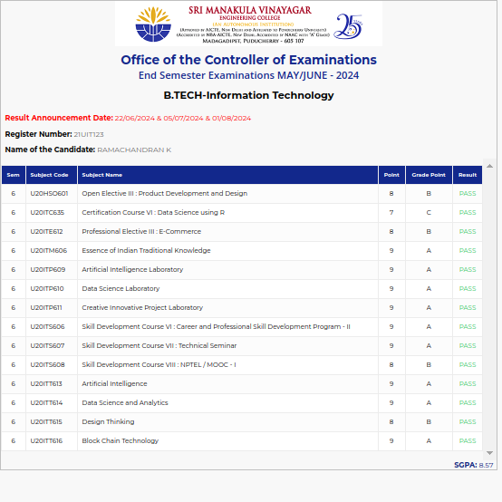

#### 21UIT127 RESHMA BEGUM S

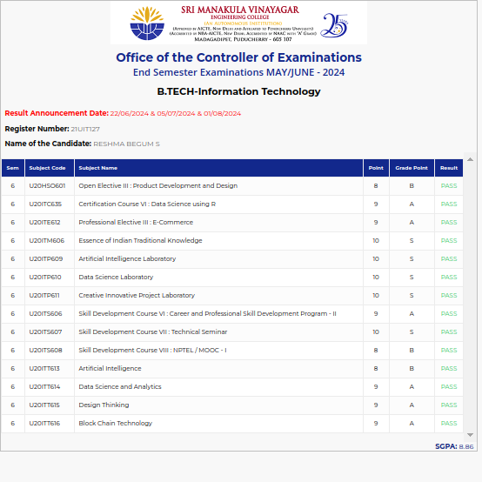

#### 21UIT133 ROGIND C

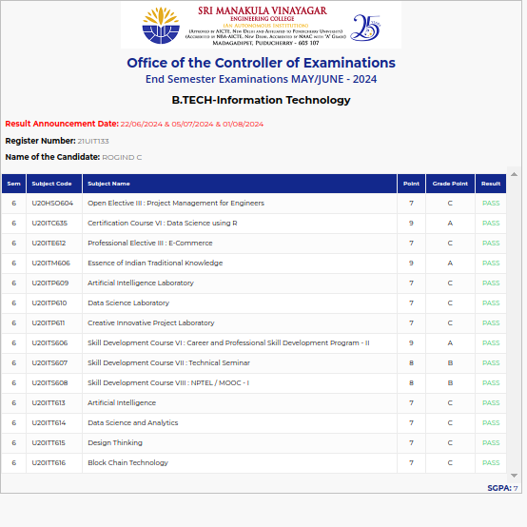

#### 21UIT134 ROSHBA B

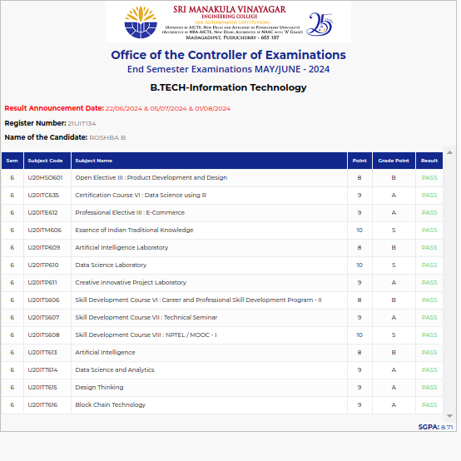

#### 21UIT148 SATHESH M A

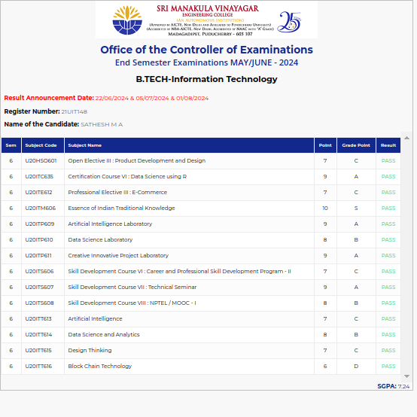

#### 21UIT153 SHIAMAMADANKI RAMALINGAME

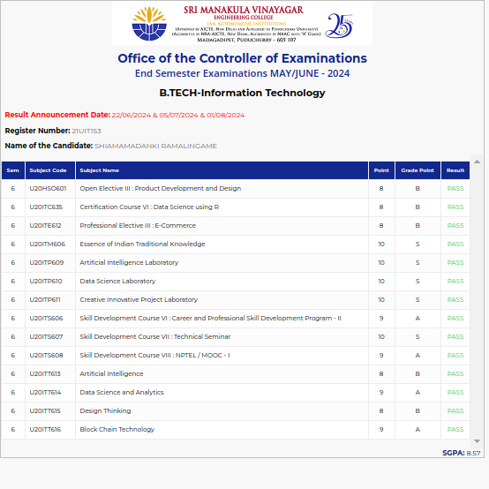

#### 21UIT156 SIBIMADHAVAN J

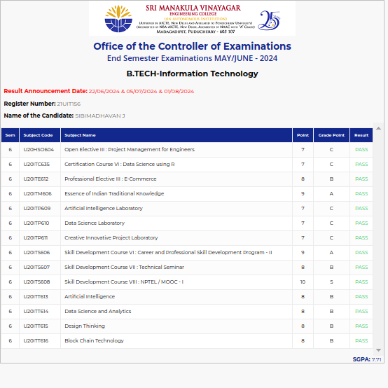

#### 21UIT157 SIVASAKTHI S

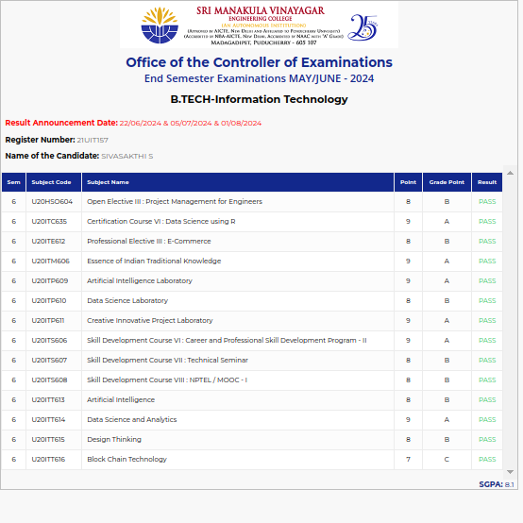

#### 21UIT159 SRIKANTH K

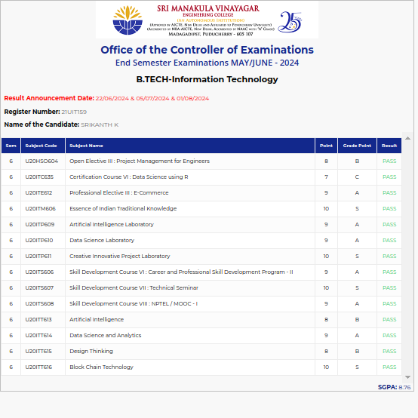

#### 21UIT160 SRIMANO S

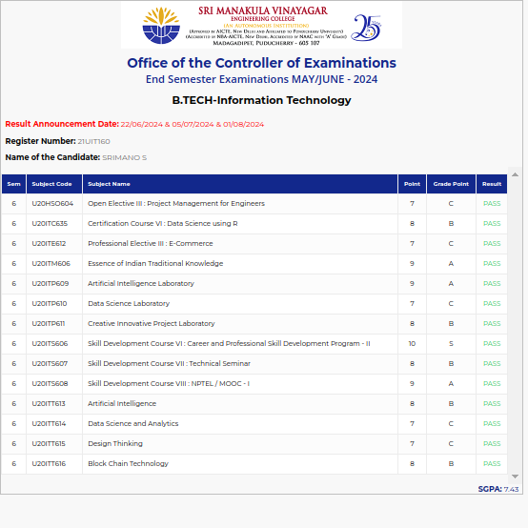

#### 21UIT163 SUDHAGARAN G

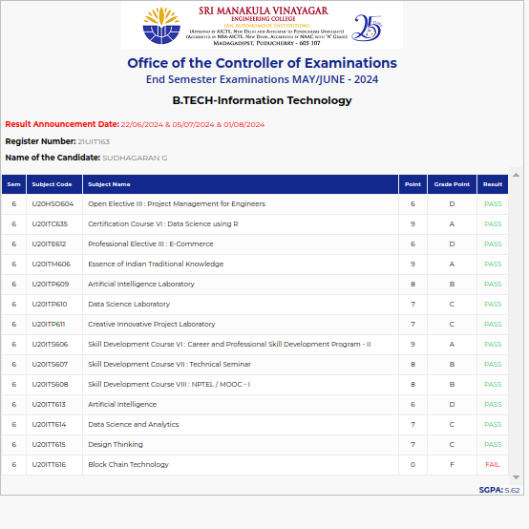

#### 21UIT167 SURENDAR P

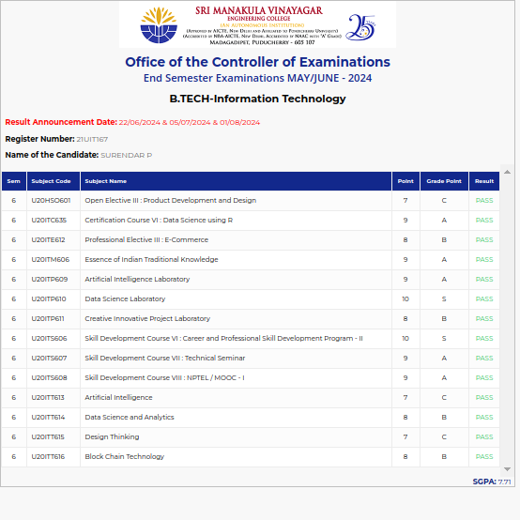

#### 21UIT170 SWATHI A

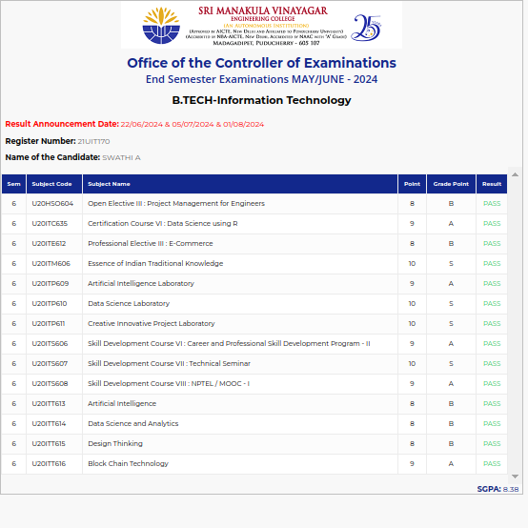

#### 21UIT171 THARA CHEZIAN B

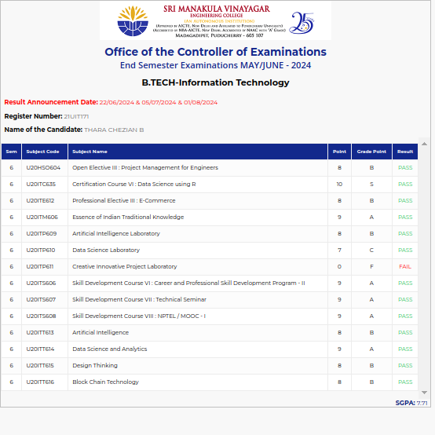

#### 21UIT174 UDHAYA RAJESHWAR R

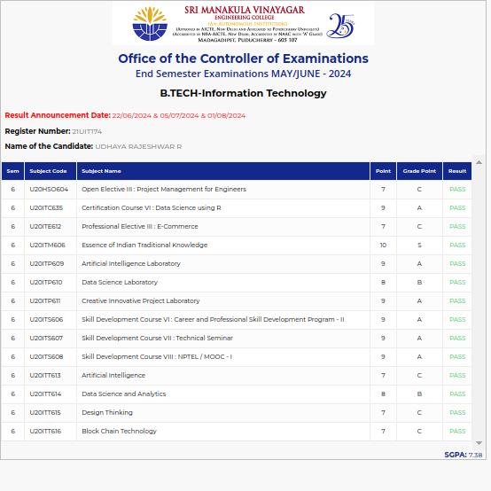

#### 21UIT179 VIVEKA N

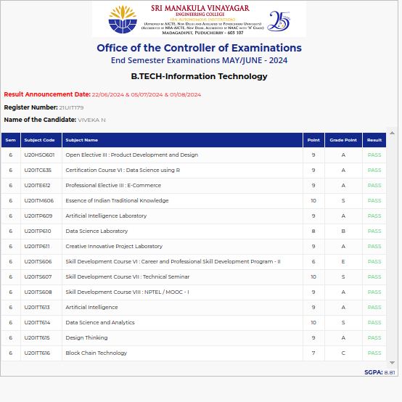

#### 21ITL003 KIRTHIGA R

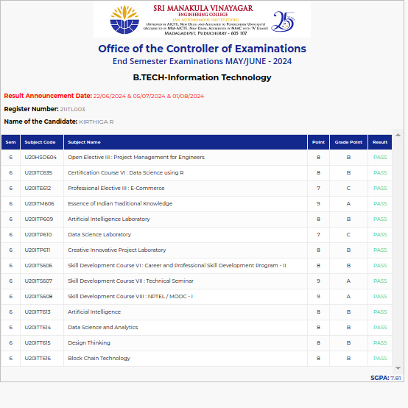

#### 21ITL006 NOORUL AMEEN J

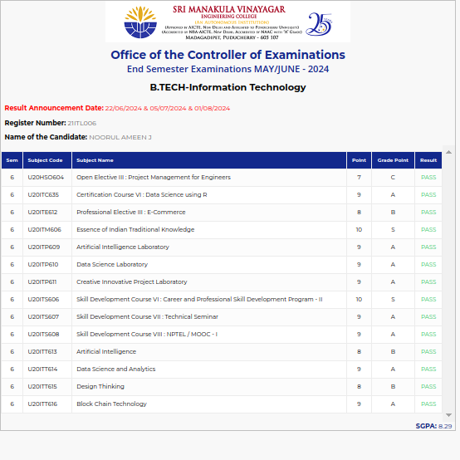

#### 21ITL007 RAHUL R

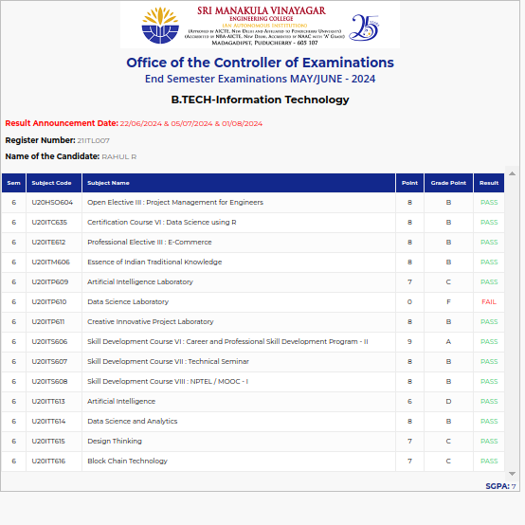

#### 21ITL009 VIGNESHWARAN V

